**Name- Mulugeta Weldegebriel Hagos ID- 850169962 Mid Semester Project**

**Introduction:**

Continuous measurement of atmospheric conditions such as temperature, relative humidity and CO2 level is essential to monitor their effect on human being and ecosystem. Low cost opensource hardware sensors are enable us to achieve such measurements. In this project two sensors known as Adafruit SHTC3 (Temperature and humidity sensor) and Adafruit SCD 40 CO2 sensor (T/RH and CO2 sensor) are integrated with Arduino micro controller to measure T/RH and C02 level for 3 consecutive days. Then the data were logged to SD card for later analysis.

**The experimental design:**

Adafruit SHTC3 temperature and relative humidity sensor was integrated with Adafruit SCD 40 CO2 sensor to measure temperature, RH and CO2 concentration. Data from both sensors was logged to an SD card module. The system was programmed on Arduino micro controller. The first step is to include all libraries necessary to run the system and the two sensor and SD card module were initialized. The Arduino operates on a loop controlled by mills () function for 3 consecutive days. At the beginning of every cycle LED is turned on for 5 seconds indicates that, the sensors begin to read. The SHTC3 sensor first read temperature and relative humidity followed by SCD 40 CO2 sensor (which measure T/RH and CO2). Then the mills (), T, RH and CO2 from both sensors are printed to serial monitor, at the same time logged to SD card. At the end of every cycle LED is turned off for 5 seconds.

**Table 1. Cost of materials**

|  |  |  |  |
| --- | --- | --- | --- |
| No | Materials | Cost | Link |
| 1 | Adafruit SHTC3 T/ RH sensor | $ 6.5 | <https://www.adafruit.com/product/4636> |
| 2 | Adafruit SCD 40 CO2 sensor | $44.95 | <https://www.adafruit.com/product/5187> |
| 3 | Arduino Microcontroller | €21,96 | <https://store.arduino.cc/products/uno-r4-minima?queryID=f8989e8d88a0bce452e1e97b735216fd> |
| 4 | Micro SD card | $9.95 | <https://www.adafruit.com/product/2693> |
| 5. | Wires | $0.95 | <https://www.adafruit.com/product/4209> |

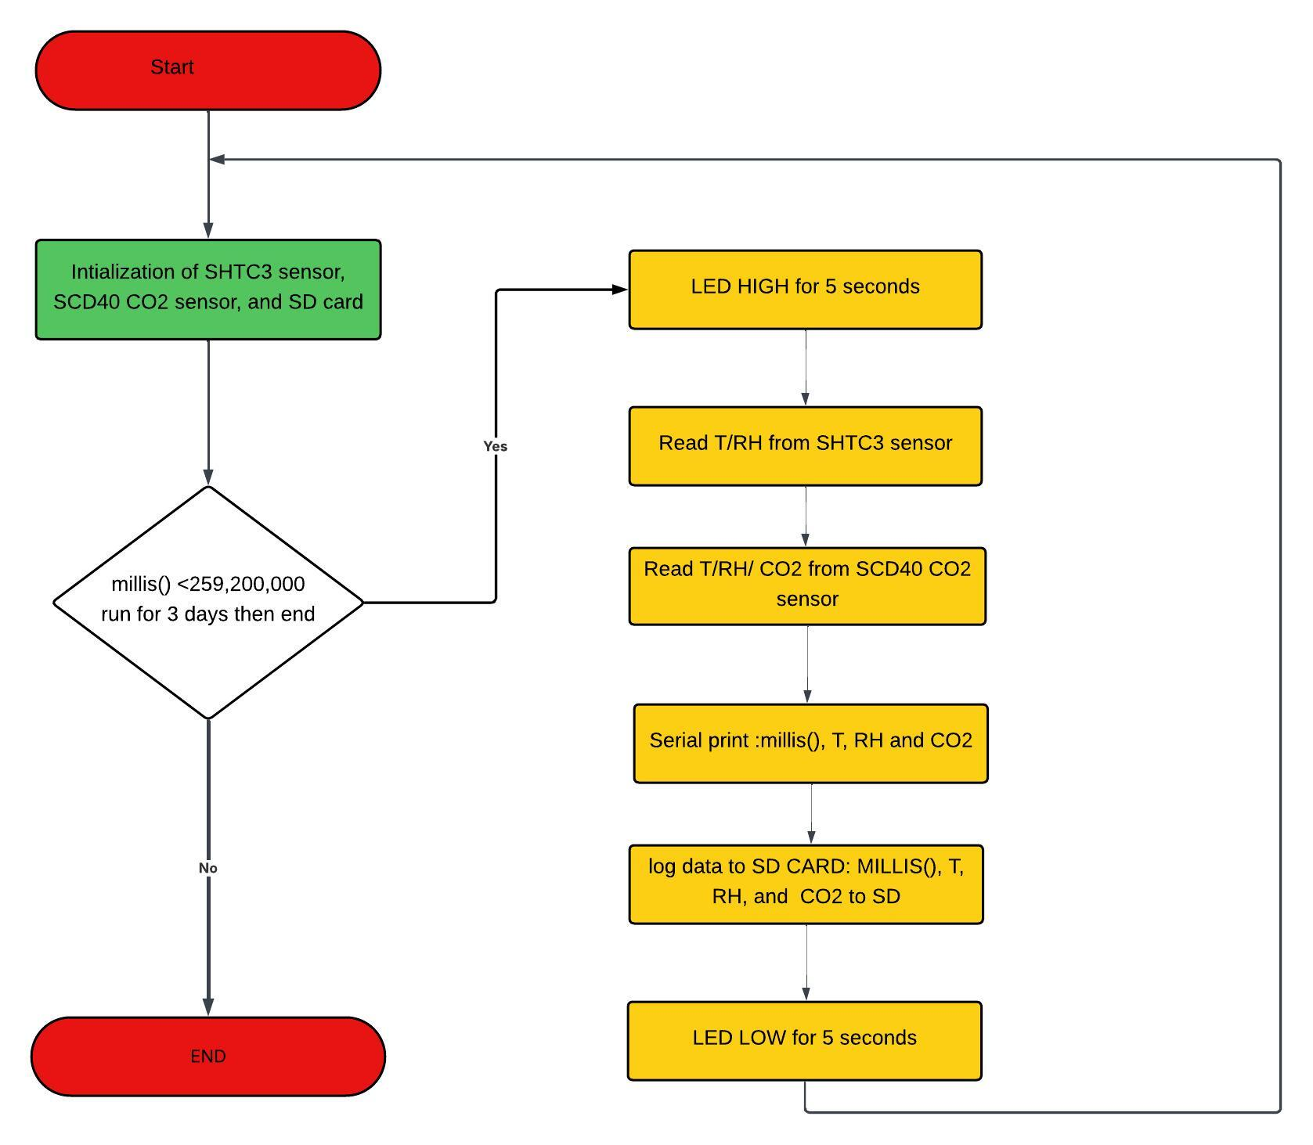

Figure 1. Diagram sketching: flow chart of the system using lucid software

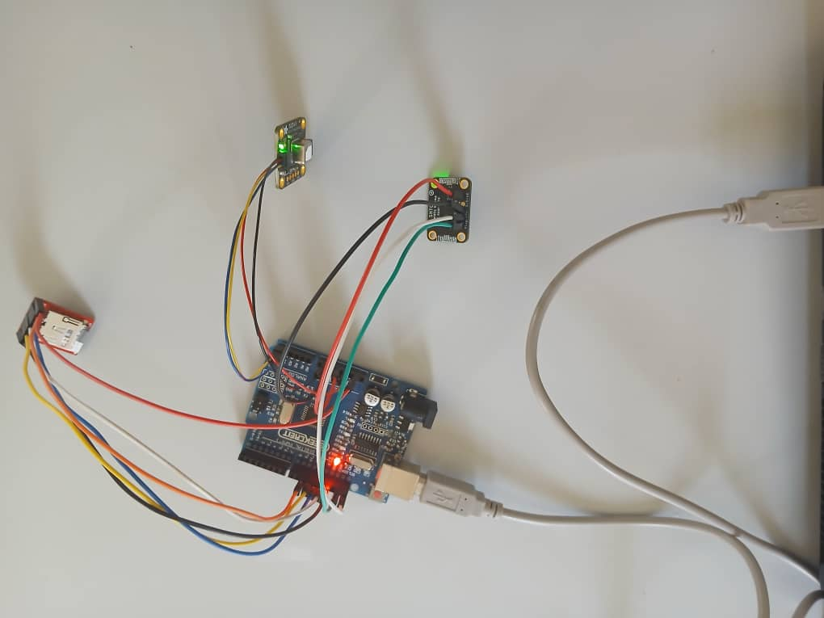

Figure 2. Adafruit SHTC3 sensor, Adafruit SCD40 CO2 sensor and Micro SD integrated via Arduino microcontroller

**Result:**

Figure 3. Temperature versus time

Figure 4. Relative humidity versus time

**Comparison Temperature measurement:**

* Both sensors follow **similar trends** throughout the experiment. However, the **SHTC3 (blue) reads consistently slightly higher** than the SCD40, especially early in the time series. Around 12,000 seconds (~3.3 hrs), there's a noticeable dip in both sensors, more prominent in the SCD40. Which Indicates a potential disturbance — maybe power or airflow change.

**Comparison Relative humidity measurement:**

* **SHTC3** readings (blue) are consistently higher than the **SCD40** (orange). The difference between the sensors appears to be about 2–3% RH on average. Despite the offset, the trends match closely, indicating good correlation. Overall, The **SCD40 (orange line)** shows a **smoother curve** with **less noise/spikes.**

Figure 5. CO2 concentration(ppm) versus time (sec)

**CO2 measurement:**

**Initially** CO₂ rises from ~500 ppm to ~770 ppm, this is Possibly because the experiment starts at might inside closed room. In the **Middle Period (~9,000–27,000 sec) its** level drop and stabilize around **600–800 ppm**, with some fluctuation, this suggests improved ventilation or fewer CO₂ sources during this time (during day). and in the **Final Phase (~27,000–48,000 sec)** CO₂ levels gradually increase and then **spike beyond 1,000 ppm,** which indictates increasing occupancy, reduced air circulation, and night-time build-up.

**Sensor Behaviour**

The SCD40 shows smooth yet sensitive response to environmental changes. Peaks are realistic and not noisy — suggesting good measurement stability and resolution.

**Limitation:**

Due to unknown reasons, the sensor stops after running for 13 hours. This may be caused by an unintentional power cut or an SD card error. Therefore, we should ensure whether it is working correctly every time or not.

**Conclusion:**

Both sensors demonstrate good agreement in trend behaviour across temperature and humidity. the SCD40 sensor appears to offer greater stability and lower measurement noise, especially in relative humidity and CO₂ data. The observed variations in CO₂ levels correlate with likely changes in occupancy and ventilation, highlighting the sensor's ability to capture environmental dynamics over time.